Analysis of Alex Greenwood -2025 UEFA Women Euro

Report by: MABEL FAFALI KWADZO
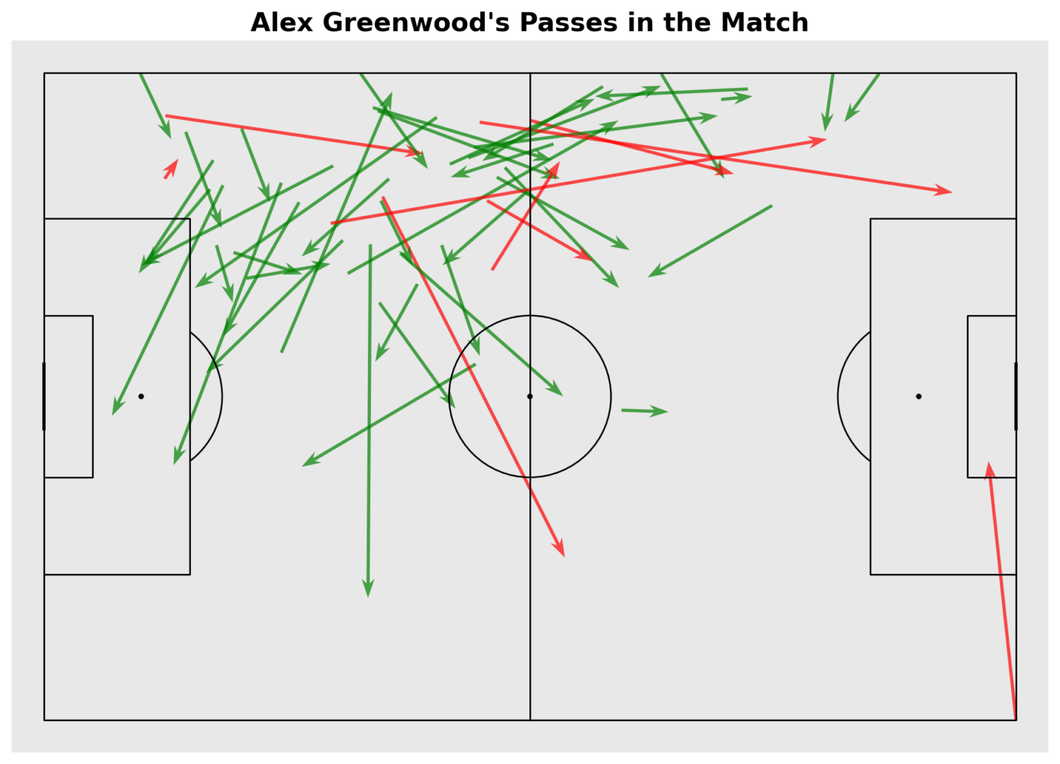
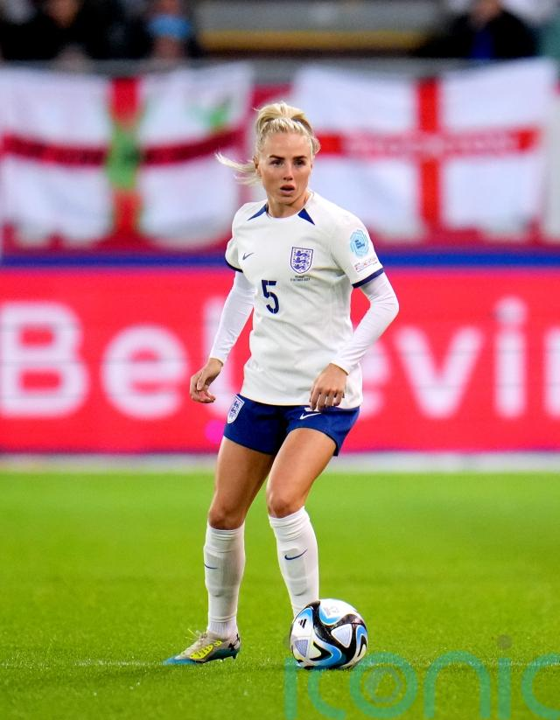
Link to streamlit: https://mabel-soccermatics-assignment-1.streamlit.app/

In the Womens Euro 2025, the player of interst for my analysis was Alex Greenwood
Alex Greenwood is a key defender for the England Women’s National Team, known for her composure, passing quality, and ability to play both centre-back and left-back. She was part of the England squad that won the European Championship in 2022.
With her experience and leadership, she remains an important part of England’s defensive structure.

Alex Greenwood delivered a strong performance for England, completing a total of 51 passes, including throw-ins. Her distribution showed good variety, with ground passes making up the majority of her involvement, reflecting her key role in building play from the back. This was followed by a solid number of high passes, used to switch play and relieve pressure, and then low passes, which she used in tighter areas.
Overall, Greenwood’s passing consistency and decision-making helped maintain England’s rhythm and supported the team’s ability to progress the ball effectively throughout the match.

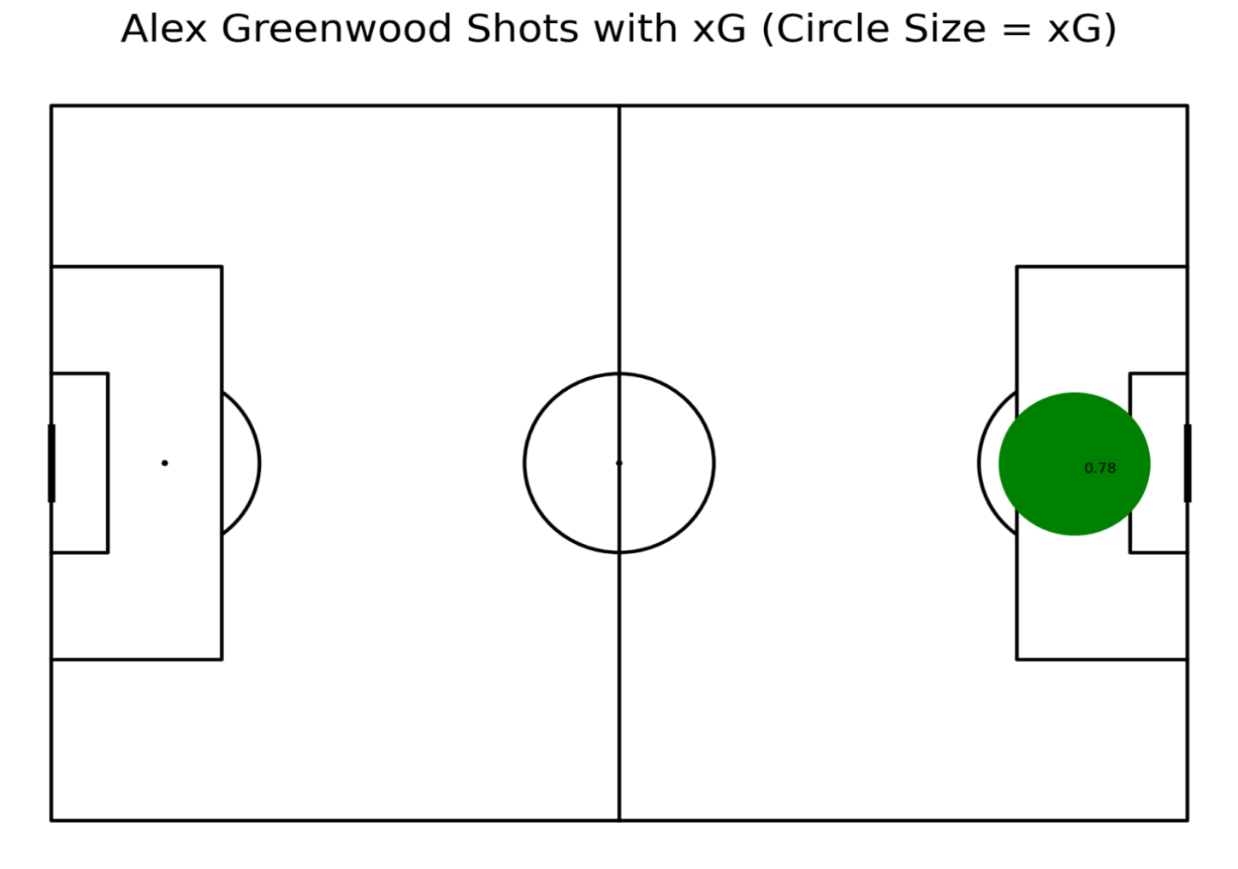
Greenwood also contributed offensively, taking one shot, which resulted in a goal. The chance carried a high xG of 0.78, reflecting the quality of the opportunity and her composure in converting it. This goal further highlighted her impact on both sides of the pitch.

References:
- Plotting Shots - Soccermatics documentation
- Plotting Passes - Soccermatics documentation
- england-vs-spain lineups

